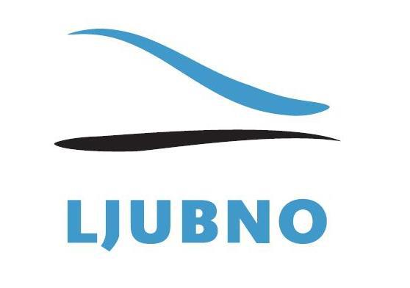

AKREDITATION FORM

PERSONAL DATA
Name and surname
Date of birth
Phone number
Email address
MEDIA
Name
Type of media
Address
State
REQUIREMENTS
Phone
Internet
Electrical connection
Other
ACCOMMODATION
Bed
Bed &breakfast
Half-board
Full-board
Program for accompanying family

Please send filled form to: info@ljubno-skoki.si, or:
SSK Ljubno BTC
Plac 2
SI - 3333 Ljubno ob Savinji
Slovenia

Deadline submission: Sunday, 8. February 2015!

